Cameron Bentz  
CSC-487  
Halil Bisgin  
2 March 2025  
  
Lab 5  
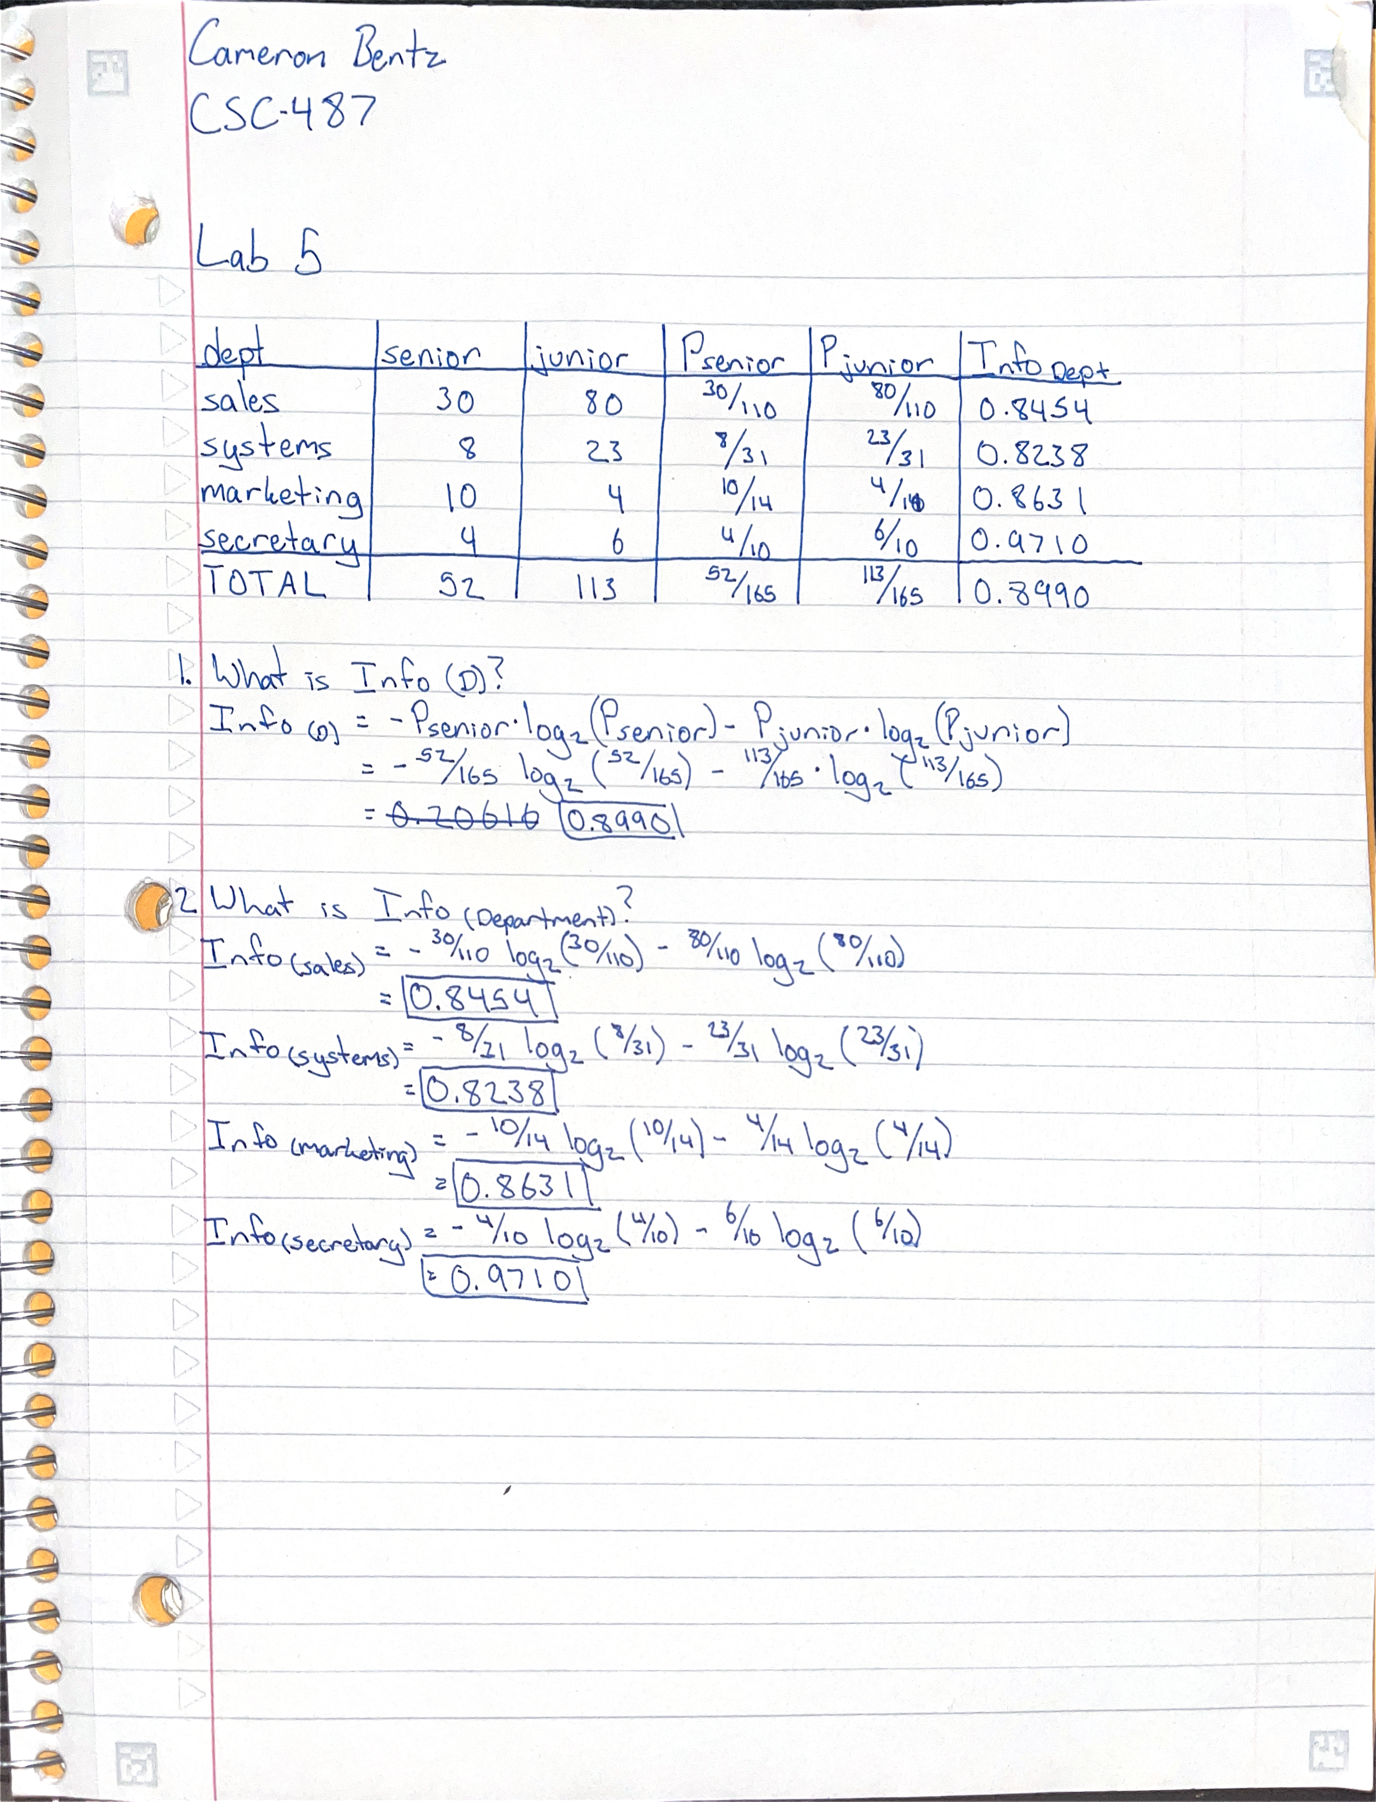  
  
  
  
  
  
Desmos Calculations  
